durham college | course facilitator: Marcos bittencourt

Evaluation Report

Mahesh Kumar B

Saravanan Balasubramanian

**INTRODUCTION**

Sentiment analysis – otherwise known as opinion mining is being used in range domains for various purposes. The prime objective is to understand the attitude, opinions, and emotions of people towards a particular subject. This is being achieved by speech synthesis using NLP and, facial expression recognition using computer vision techniques. A clear such analysis of sentiments helps to determine the businesses to shape their strategies towards improvement.

Our idea is to develop an application to detect real-time facial expressions using computer vision for clothing showrooms. This system can identify the customer’s attitude towards the products and the arrangement mechanism in the showroom. This helps the businesses to understand the trends and interests of clothes and accessories plus the arrangement priorities of the showroom.

**DEPLOYMENT MODEL**

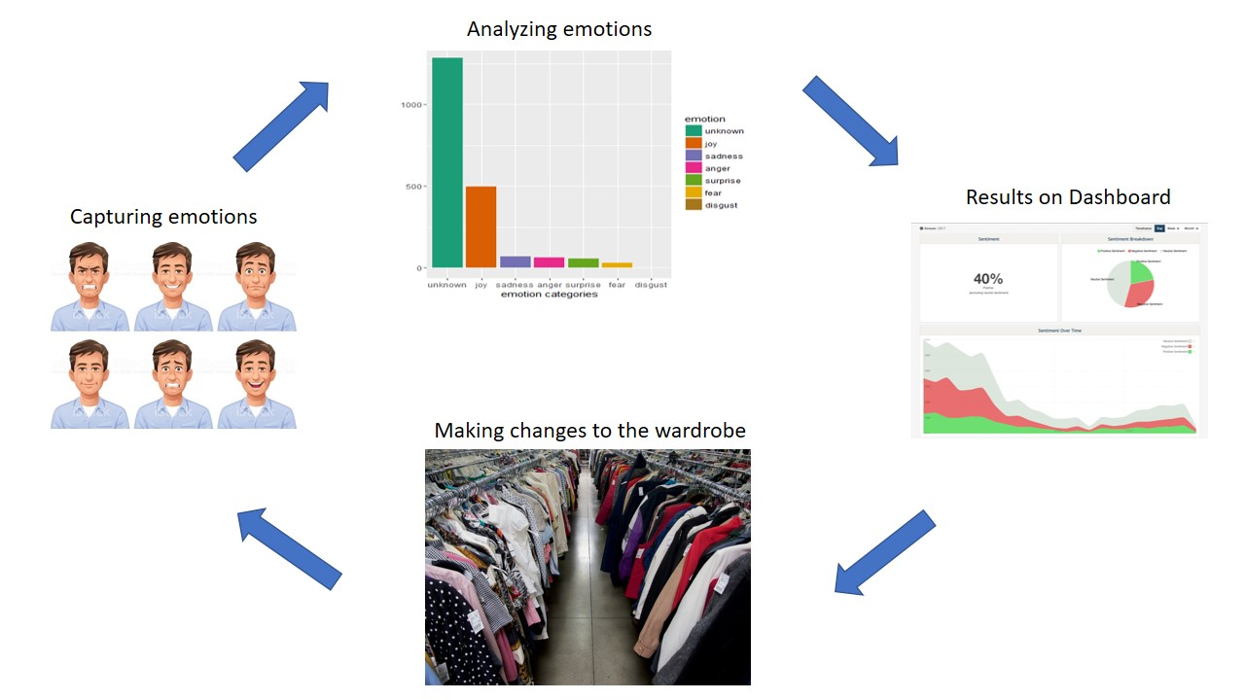

Our system will capture real time video frames and send it to the model for analysis. The analysis results will be visible in the dashboard. Shop owner/ Management can make decisions based on the results and make changes to their clothing sections.

**KEY FINDINGS AND RESULT:**

1. **Model Evaluation**

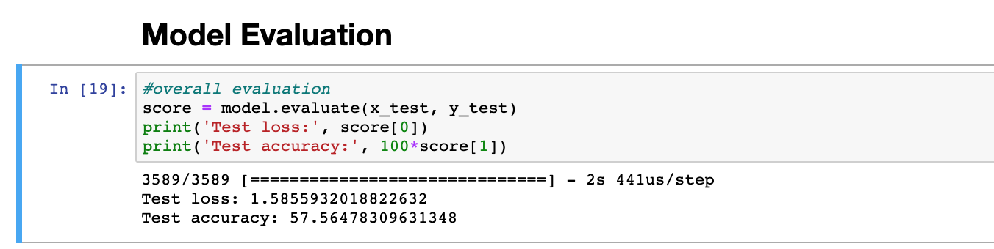

1. 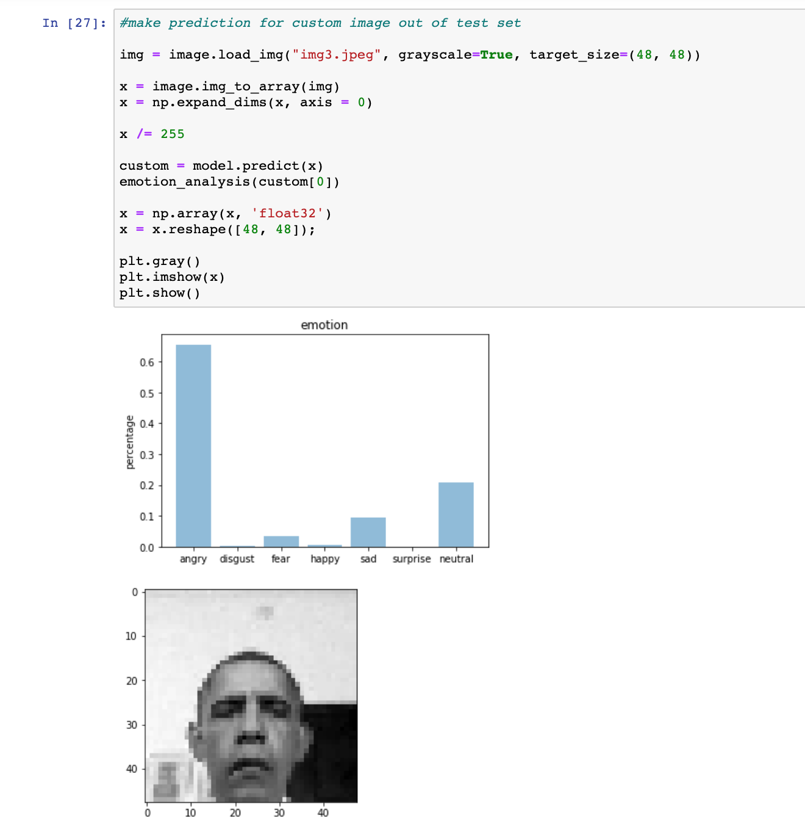**Predicted results**

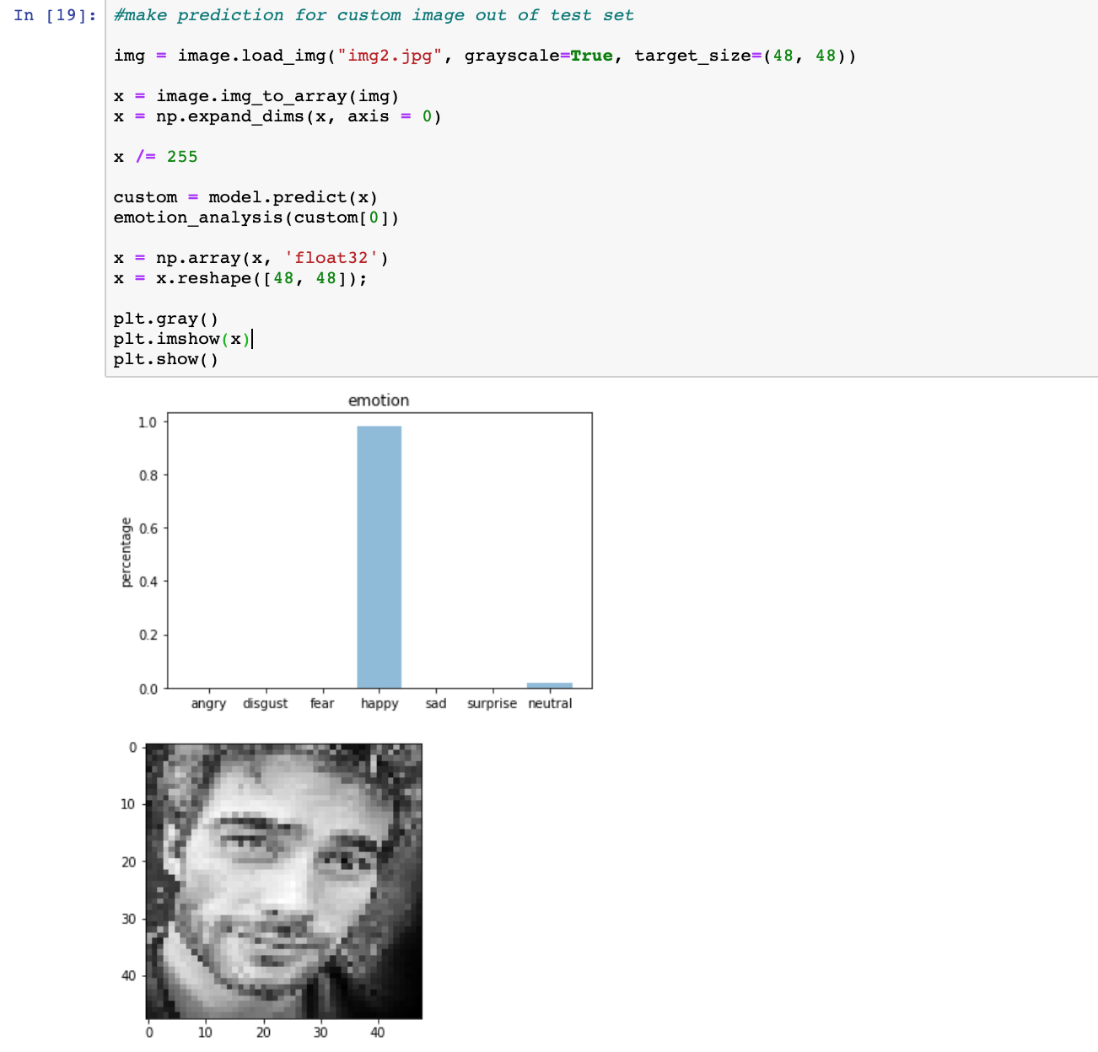

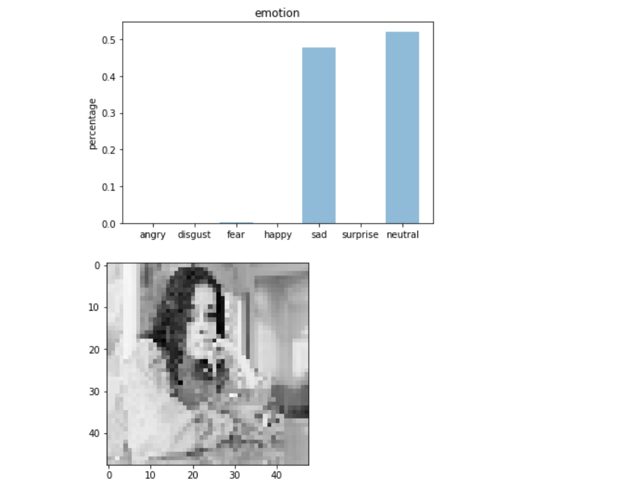

**User Interface:**

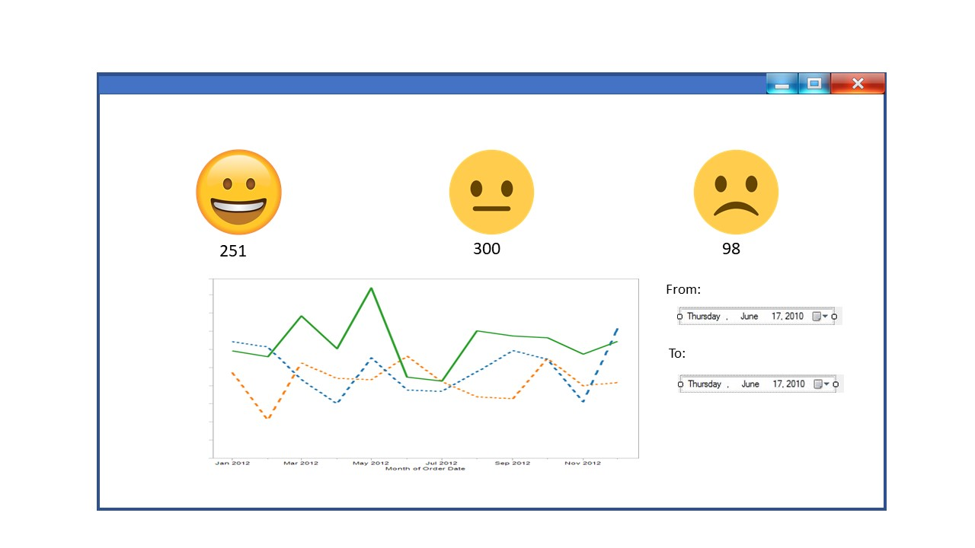

**Advantages and Disadvantages:**

**Advantages:**

* Convolutional neural networks revolutionized the computer vision industry. It has have greater capabilities for image pattern recognition and sentimental analysis.
* All the seven emotions are combined to three emotions which are needed for the organization for optimum results.

Angry, disgust, fear and sad to SAD.

Happy, surprise to HAPPY.

Neutral is set as Neutral.

* More informed decision for inventory management. The inventory can be updated / Modified according to the customer preference.
* The system retains user data for a long time, this can be used for business analytics. For instance we can find out, in the year 2019, what types of dress got most positive emotions.
* More profit, since the model will help boost the sales, it is expected an increment in profit.
* Early adaptation, since it’s possible to analyze the customer reaction for brand new clothes, we can predict the trends early, and this will help.

**Disadvantages:**

* The training dataset comprises of only 48*48 pixel images. This makes it harder to recognize patterns in high resolution images.
* The number of training samples in the dataset is low. With large number of training data the deep learning algorithm can learn more patterns.
* Sometimes, sad faces are considered as neutral. This may be due to the bias in the training dataset.